CHAPTER -2 ADAPTATION –HOW PLANTS SURVIVE

- Oral question-
- Why do you think only mangrove plants can grow in marshy areas?
Ans. Only mangrove plants grow in marshy areas because only they have breathing roots.
- How does lotus remain afloat?
Ans. Lotus have hollow and light stem that keep the leaves and the flower afloat.
- Why do some plants have thorns on their bodies?
Ans. Some plants have thorns on their bodies to protect them from animals.
- Science Quiz-
- Name the desert plant?
Ans. Cactus
- Where can pine and fir trees grow well?
Ans. Pine and fir tree grow well in mountain regions.
- Name a plant in which stem prepares and stores food.
Ans. Plants in which stem prepares and stores food are –cactus, Aloe-Vera.
- Name a carnivorous plant.
Ans. Pitcher plant
- Name a saprophytic plant.
Ans. Coral root
- Short Answer Question-
- What is a desert?
Ans. Hot and dry places are called desert.
- What happens when we touch a poison ivy plant?
Ans. When we touch poison ivy plant our skin start itching.
- The roots of mangrove plants grow out of the soil to breathe and thus, adjust to the marshy region they grow in.
- Which type of soil is found in marshy places?
Ans. Marshy places have sticky and clayey soil.
- What values do we learn from plants that adapt to their environment?
Ans. We learn to adapt ourselves in all conditions.
- Why do we not find mango plant on mountains?
Ans. Mango plants not found on mountains because mango grows only in plain regions which is neither too hot nor too cold.
- Give two adaptations in plants that grow in mountain region.
Ans. Two adaptations in plants that grow in mountain regions are-
- Trees are tall, straight and thin.
- Their leaves are thin and needle like.
- Long Answer Questions-
- How does a desert plant adapt itself in desert conditions?
Ans. A desert plant adapt itself in desert in following ways-
- Leaves changes into spines.
- Stem prepare food in place of leaves.
- Roots spread out deep under the ground.
- Discuss the features of plants that grow in plains.
Ans. Features of plants that grow on plains-
- Trees have many branches.
- Their branches have many flat and thin leaves.
- Leaves help in evaporating excess water keeping them cool.
- What difference do you find in terrestrial and aquatic plants?
Terrestrial Plants | Aquatic Plants
- They grow on land. | They grow on water
- They have stomata | some plants do not have stomata
- They have well developed roots. | They do not have well developed roots.
- Leaves do not have waxy coating. | Leaves have waxy coating.

- Think and Answer-
- Coral root is a non-green plant, so it cannot do photosynthesis. It is also not an insectivorous plant. Then, how is it able to get food to survive?
Ans. Coral root is a saprophytic plant. It absorb it food from remains of dead plants and animals.
- Pinky’s father is getting a big aquarium for their home. He wants some real plants to be grown inside the aquarium, so that the fishes get oxygen to breathe naturally. Which one of these should be kept inside the aquarium and why? Water hyacinth, duckweed and tape grass.
Ans. Tape grass should be kept inside the aquarium because it is underwater plants which grow and remain under the water.
- Match it-
- Floating plant wolffia
- Insectivorous plant pitcher plant
- Poisonous plant poison ivy
- Desert plant keekar
- Marshy plant swamp
- Underwater plant pond weed
- Fixed plant lotus
- Draw and Label-
- Aquatic plant- Lotus
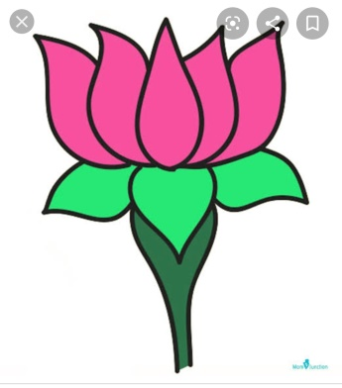
- Insectivorous plant-Pitcher plant

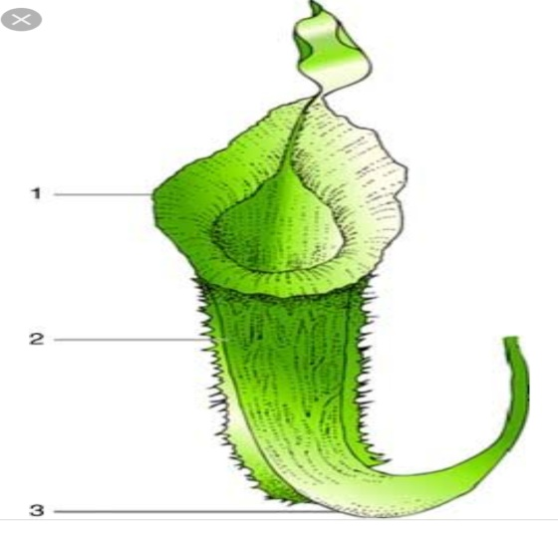
- Desert plant - Cactus
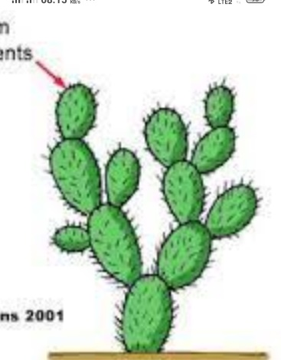
BOOK EXERCISE (solve it in the book )-
Multiple choice question-
Page 170 1(a), 2(c) 3(a)
Page 171 1(b) 2 (a) 3(a)
Page 173 1(c) 2(a)
Page 174 1(a) 2(b)
Circle the odd ones-
- Pine
- Water hyacinth
- Water hyacinth
Fill in the blanks-
- Dry
- Cactus
- Marshes
- Aquatic
- Floating

